

Search Medium

[Write](https://medium.com/new-story?source=---two_column_layout_nav----------------------------------)

[2](https://medium.com/me/notifications?source=---two_column_layout_nav----------------------------------)



Get unlimited access to all of Medium for less than $1/week.

[Become a member](https://medium.com/plans?source=upgrade_membership---post_top_nav_upsell----------------------------------)



**Gremlin Chaos Engineering On Google Cloud**

[[](https://medium.com/@onkar17?source=post_page-----2568f9fc70c9--------------------------------)](https://medium.com/@onkar17?source=post_page-----2568f9fc70c9--------------------------------)

[[](https://medium.com/google-cloud?source=post_page-----2568f9fc70c9--------------------------------)](https://medium.com/google-cloud?source=post_page-----2568f9fc70c9--------------------------------)

[Onkar Naik](https://medium.com/@onkar17?source=post_page-----2568f9fc70c9--------------------------------)

·

Follow

Published in

[Google Cloud - Community](https://medium.com/google-cloud?source=post_page-----2568f9fc70c9--------------------------------)

·

10 min read

·

Aug 8, 2022

25

This Article is based on how to implement **Chaos Engineering Experiments Using Gremlin on Google Cloud.**

**Prerequisites**

1. Google Cloud Platform Account
2. Gremlin Application Account
3. GKE Cluster

**What Is Chaos Engineering?**

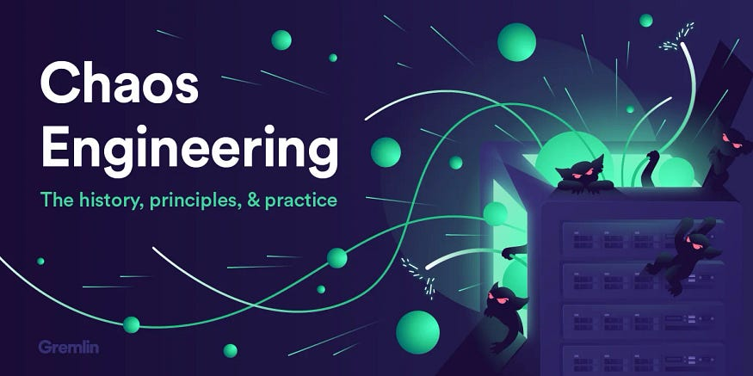

**Chaos engineering** is a method of testing distributed software that deliberately introduces failure and faulty scenarios to verify its resilience in the face of random disruptions.

***Chaos Engineering lets you compare what you think will happen to what actually happens in your systems. You literally “break things on purpose” to learn how to build more resilient systems.***

**What Is Gremlin?**



**Gremlin** is a simple, safe, and secure way to improve the resilience of your systems by using Chaos Engineering to identify and fix failure modes.

**Gremlin** is a cloud-native platform that runs in any environment. Gremlin supports all public cloud environments — AWS, Azure, and GCP — and runs on Linux, Windows, and containerized environments like Kubernetes, and bare metal.

In 2010,**Netflix** introduced a technology to switch production software instances off randomly — like setting a monkey loose in a server room — to test how the cloud handled its services. Thus, the tool [Chaos Monkey](https://netflixtechblog.com/5-lessons-weve-learned-using-aws-1f2a28588e4c) was born.

**Chaos engineering matured at organizations such as Netflix, and gave rise to technologies such as**[**Gremlin (2016)**](https://www.gremlin.com/community/tutorials/chaos-engineering-the-history-principles-and-practice/)**,** becoming more targeted and knowledge-based.

Now let's start ***Gremlin Chaos Engineering Experiments on Google Cloud*** as follows :

1. **Gremlin Shutdown Attack on GKE Pods to validate the High Availability of the application**
2. **Gremlin CPU Attack on GKE Pods to validate GKE Horizontal Pod Autoscaling**
3. **Gremlin Blackhole Attack on GKE Load Balancer to validate High Availability of web application on GKE**

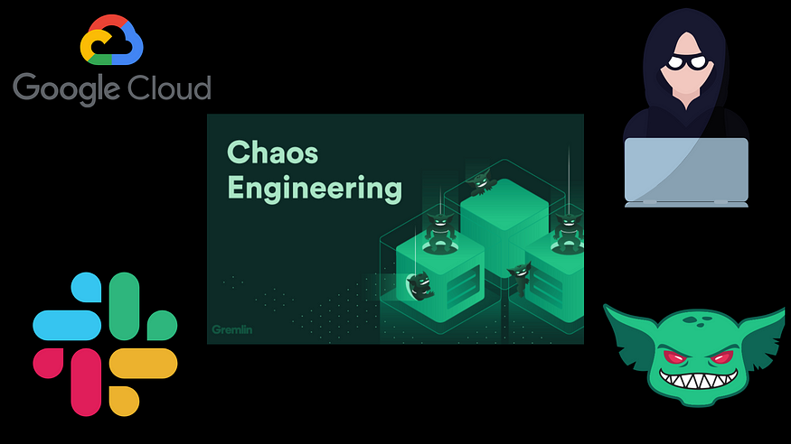

As the part of prerequisites, we already signed up for the Gremlin Web App account.

To signup for a Gremlin Web App account → <https://app.gremlin.com/signup>

In order to perform various chaos experiments on GKE, we need to install the Gremlin Kubernetes Client in GKE so that we can create various attacks on GKE from the Gremlin web application.

**Installing the Gremlin Client Agent on GKE Cluster**

To install the Gremlin Kubernetes client, you will need your **Gremlin Team ID and Secret Key**. If you don’t know what your Team ID and Secret Key are, you can get them from the Gremlin web app.

Visit the [Teams page](https://app.gremlin.com/settings/teams) in Gremlin, and then click on your team’s name in the list.

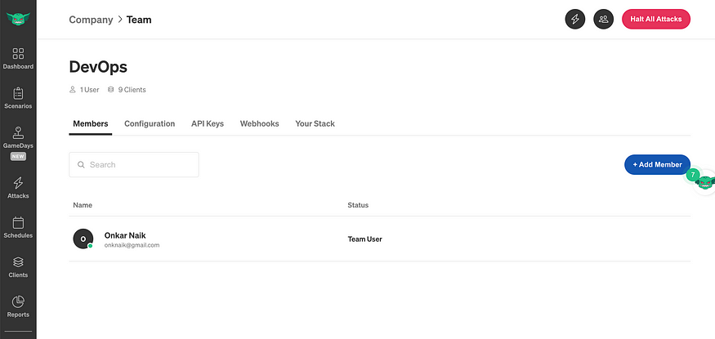

On the Teams screen click on Configuration.

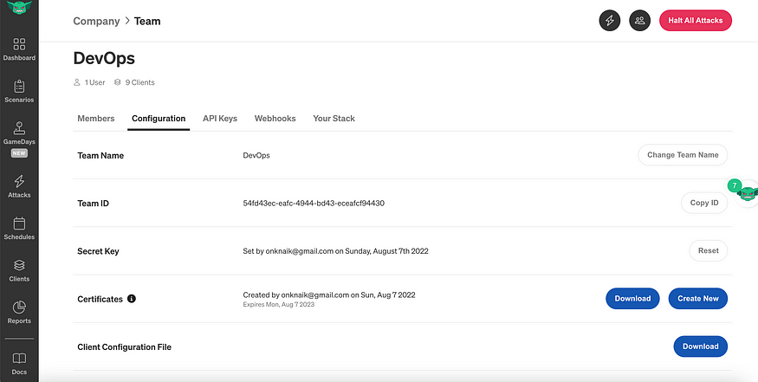

If you don’t know your Secret Key, you will need to reset it. Click the Reset button. You’ll get a popup reminding you that any running clients using the current Secret Key will need to be configured with the new key. Hit Continue.

Next, you’ll see a popup screen that will show you the new Secret Key. Make a note of it.

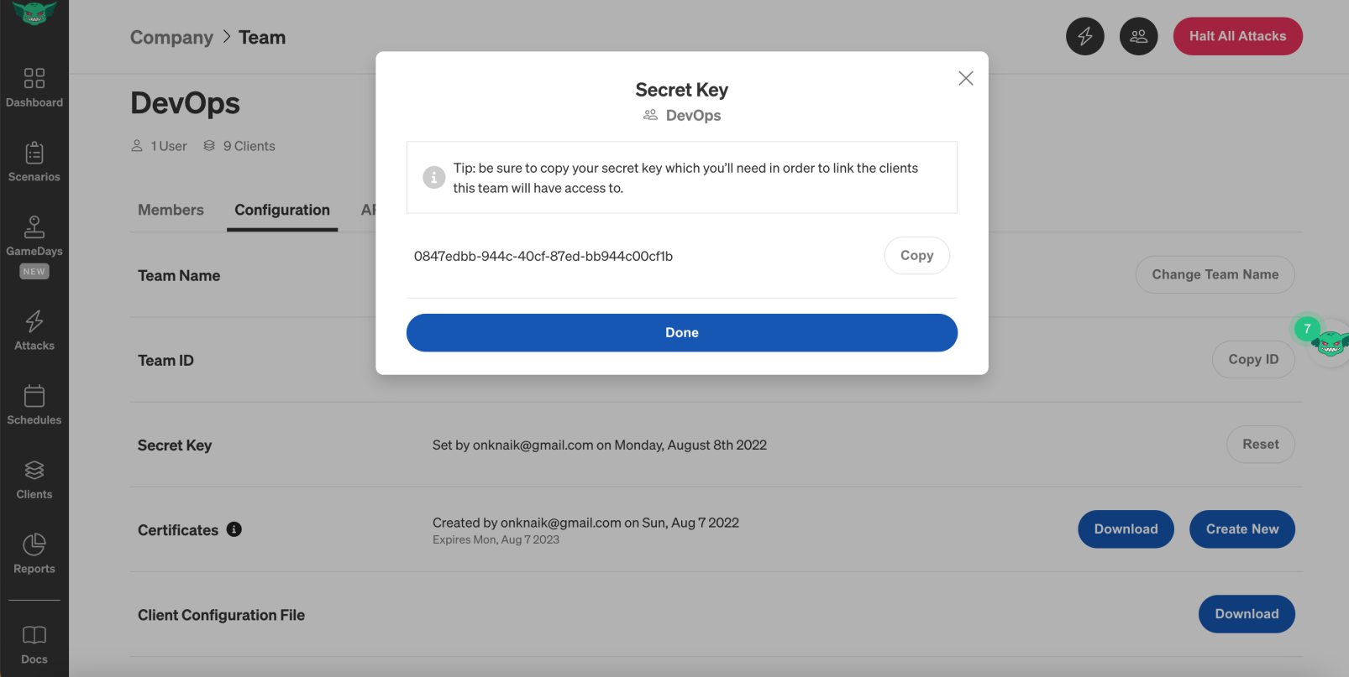

**Install the Gremlin Client with Helm**

**[Getting Started > Installing Gremlin on Kubernetes with Helm | Gremlin Docs](https://www.gremlin.com/docs/getting-started/install-kubernetes-helm/" \t "_blank)**

[You can install the Gremlin Kubernetes client in addition to installing the Gremlin client on a host - both are…](https://www.gremlin.com/docs/getting-started/install-kubernetes-helm/" \t "_blank)

[www.gremlin.com](https://www.gremlin.com/docs/getting-started/install-kubernetes-helm/" \t "_blank)

Add the Gremlin Helm chart:

helm repo add gremlin [https://helm.gremlin.com](https://helm.gremlin.com/)

Create a namespace for the Gremlin Kubernetes client:

kubectl create namespace gremlin

Next, you will run the helm command to install the Gremlin client. In this command, there are three placeholder variables that you will need to replace with real data. Replace $GREMLIN\_TEAM\_ID with your Team ID, and replace $GREMLIN\_TEAM\_SECRET with your Secret Key. Replace $GREMLIN\_CLUSTER\_ID with the name of GKE Cluster.

helm install gremlin gremlin/gremlin   
--namespace gremlin \  
--set gremlin.hostPID=true \  
--set gremlin.secret.managed=true \  
--set gremlin.container.driver=docker-runc \  
--set gremlin.secret.type=secret \  
--set gremlin.secret.teamID=$GREMLIN\_TEAM\_ID \   
--set gremlin.secret.clusterID=$GREMLIN\_CLUSTER\_ID \  
--set gremlin.secret.teamSecret=$GREMLIN\_TEAM\_SECRET

**Note:**Here in the above helm installation gremlin. container. driver value may vary as per your cluster node container runtime. In my case, I have used GKE Nodes with the Ubuntu-docker image type.

To verify that the installation was successful, run this command:

kubectl get pods -n gremlin

The output should show one chao pod and one gremlin pod for each node in your cluster. These should all be in the Running state:

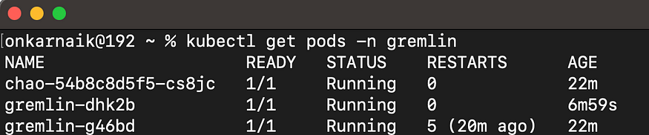

You can also check the status of the client from Gremlin Web Application

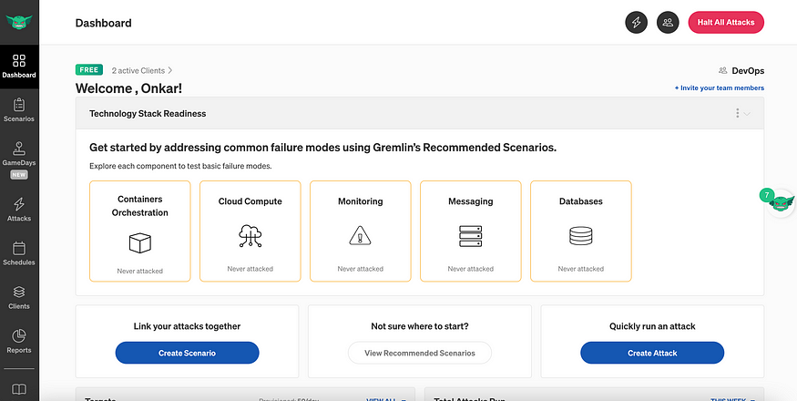

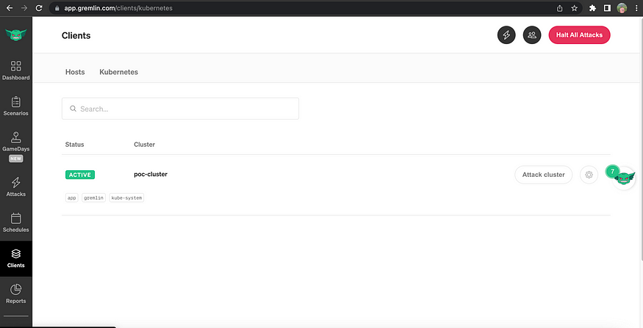

**Setting Up Slack Integration with Gremlin Web App**

We can also Integrate our Slack app with Gremlin for getting Attack reports and Notifications on the slack channel.

For setting up Slack Integration with Gremlin we have to add the slack channel In Gremlin Integration we created for getting Gremlin attacks notifications.

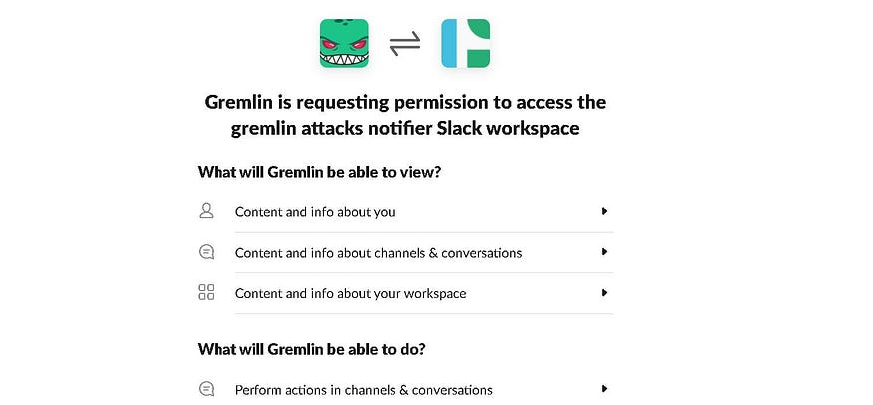

Now just select your slack channel where you want to receive Gremlin Notifications and Click Allow.

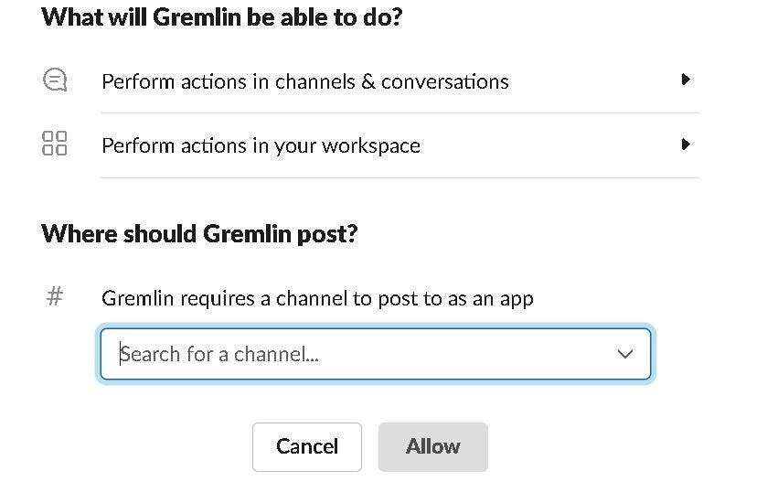

That’s all your **Slack Integration with Gremlin Is now Ready.**🎉🎉

Now we have the Gremlin Agent Installed on the GKE cluster with slack app notifications enabled.

Let us deploy one sample Nginx web application on the GKE cluster.

**Deploying Nginx Application on GKE Cluster with HPA**

1. Create a separate namespace for Nginx deployment.

kubectl create ns app

2. Deploying Nginx deployment in app namespace.

kubectl apply -f nginx.yaml

3. Exposing Nginx Deployment with GKE Load Balancer.

kubectl expose deployment myapp --type=LoadBalancer --port=80

4. Deploying Horizontal Pod Autoscalar for Nginx Deployment.

kubectl apply -f hpa.yaml

5. Check all resources deployed correctly or not using the below command.

kubectl get all -n app

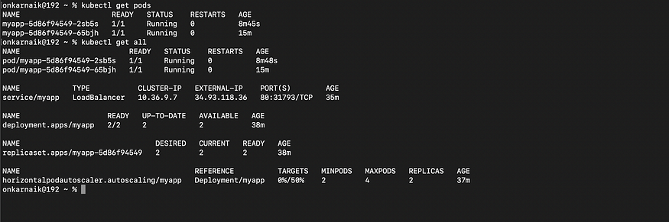

We can now start performing various chaos experiments or attacks on Nginx sample deployment to validate various things like monitoring, alerting, scaling and availability, etc working or not.

**Gremlin Attacks**



**An attack is a method of injecting failure into a system in a simple, safe, and secure way.** Gremlin provides a range of attacks that you can run against your infrastructure. This includes impacting system resources, delaying or dropping network traffic, shutting down hosts, and more. In addition to running one-time attacks, you can also schedule regular or recurring attacks, create attack templates, and view attack reports.

Gremlin provides three categories of attacks:

* **Resource attacks:** test against sudden changes in consumption of computing resources
* **Network attacks:** test against unreliable network conditions
* **State attacks:** test against unexpected changes in your environment such as power outages, node failures, clock drift, or application crashes

We are going to perform one attack from each of these types of attacks on the Nginx Deployment to validate various aspects of our system.

**Validating High Availability with Gremlin Shutdown Attack**

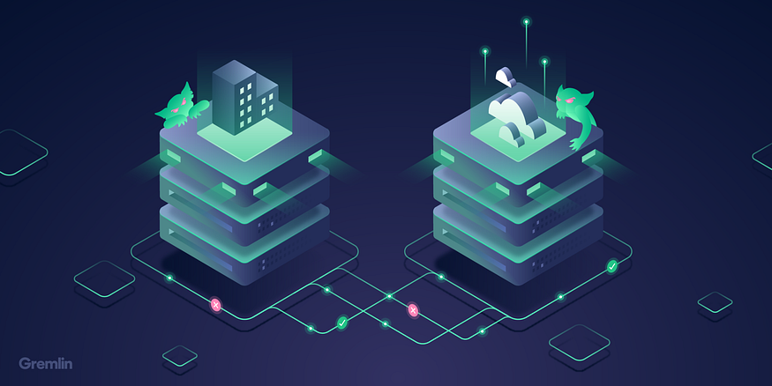

**Shutdown attacks** let teams build resilience to host failures by testing how their applications and systems behave when an instance is no longer running.

**Configuring Gremlin Attacks for Nginx Deployment**

Go to Attacks Menu in Gremlin Web App Console → Select Kubernetes → Choose a Cluster and Namespace ( where the target app is present )

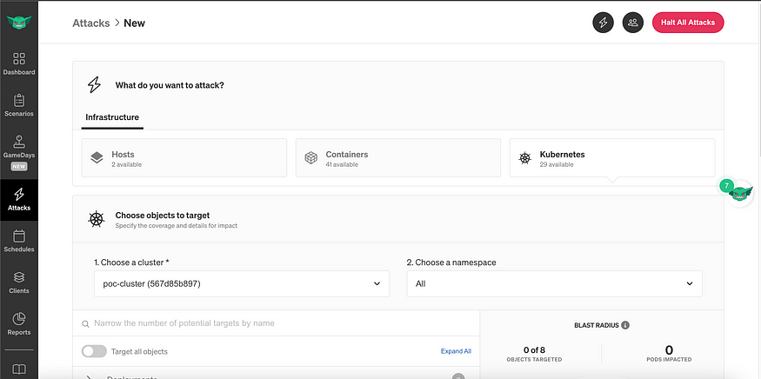

Select the target Deployment on which Gremlin performs the attack and define the blast radius for the attack.

**Blast Radius: Number of hosts included or amount of target part in the attack**

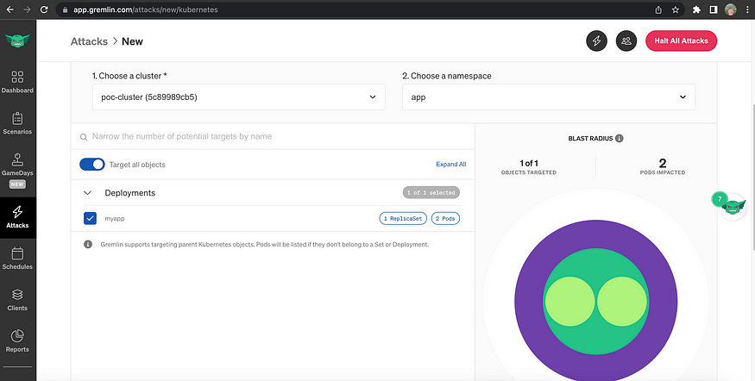

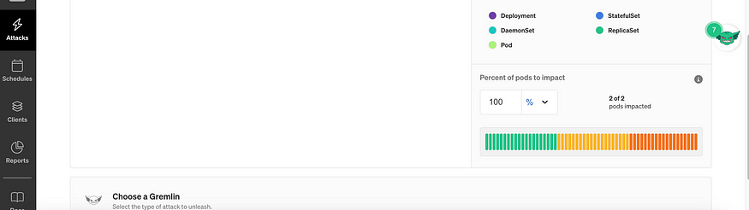

For Shutdown, Attacks choose the type of attack as Shutdown attack from State Attacks.

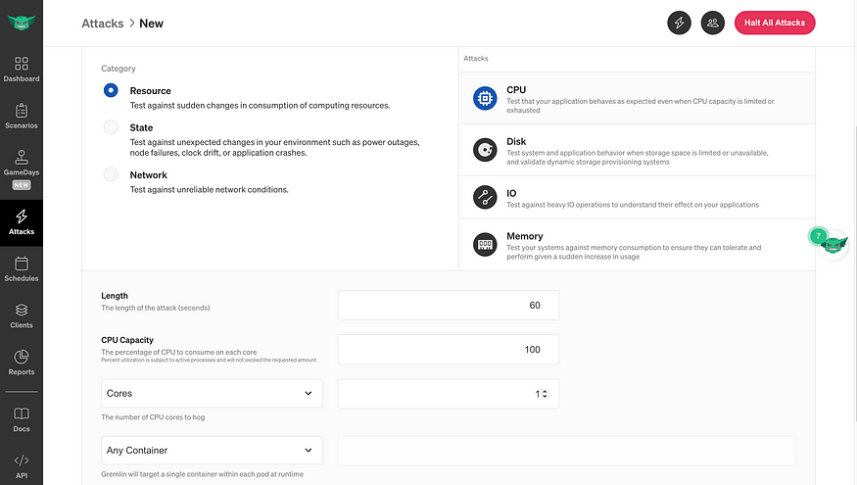

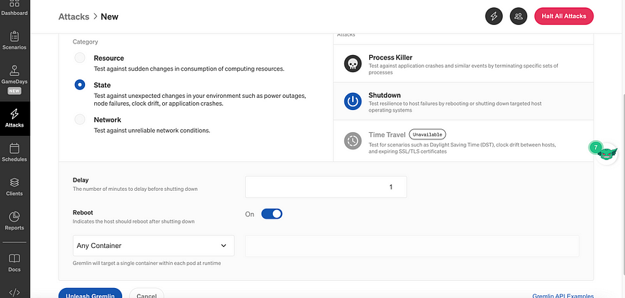

Click on unleash Gremlin to Run the particular Attack.

**Running Gremlin Shutdown Attack**

Click on attack details to see the attack details and output of the attack which Gremlin is running on Nginx Deployment Pods.

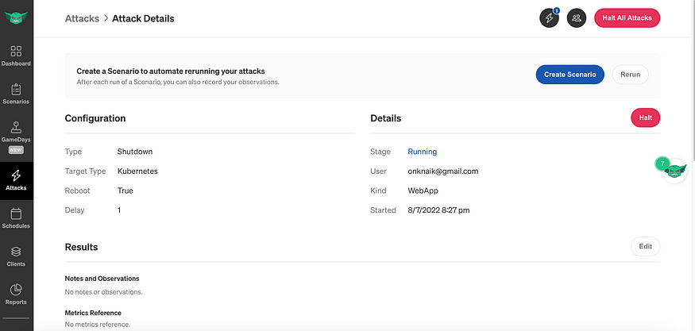

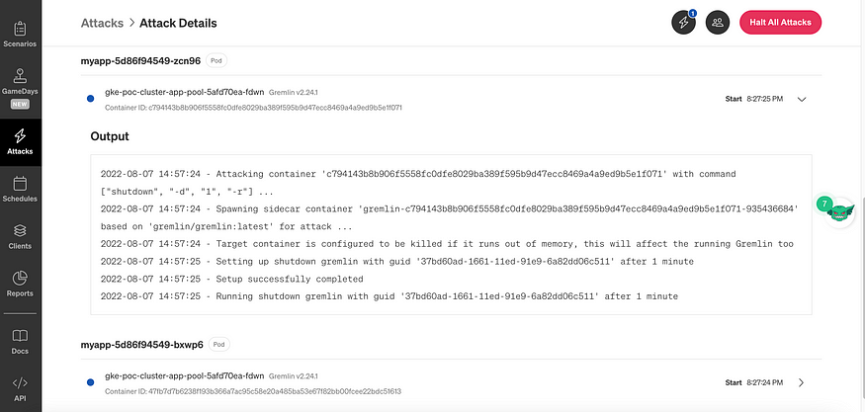

We can see that the Nginx Deployment is highly available even while running the shutdown attack due to more replicas.

kubectl get pods -n app -w

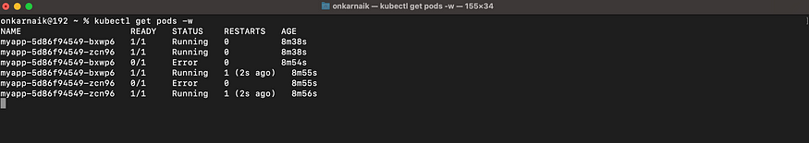

**A shutdown Attack can answers questions such as:**

* How long does it take for an instance to restart? Does my application successfully restart when the instance comes back online?
* Does my load balancer automatically reroute requests away from the failed instance? Do I have other instances available to handle these requests?
* If a user has an active session on an instance that fails, does the session gracefully continue on a different instance?
* Is there any data loss? Are ongoing processing jobs restarted?

**Validating GKE Horizontal Pod Autoscaling with Gremlin**

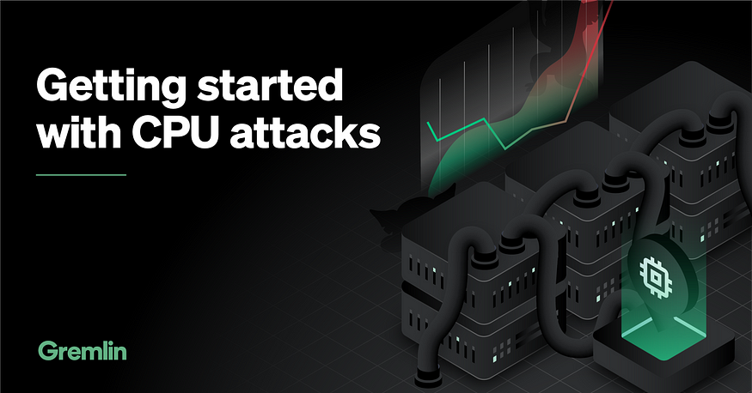

CPU attacks help you ensure that your application behaves as expected even when CPU capacity is limited or exhausted. CPU attacks can also help test and validate automatic remediation processes, such as auto-scaling and load balancing.

For CPU Attack choose the type of attack as the CPU attack from Resource Attacks and configure more details for the attack like attack duration time, target CPU capacity going to be impacted, etc.



**Running Gremlin CPU Attack**

Click on attack details to see the attack details and output of the attack which Gremlin is running on Nginx Deployment Pods.

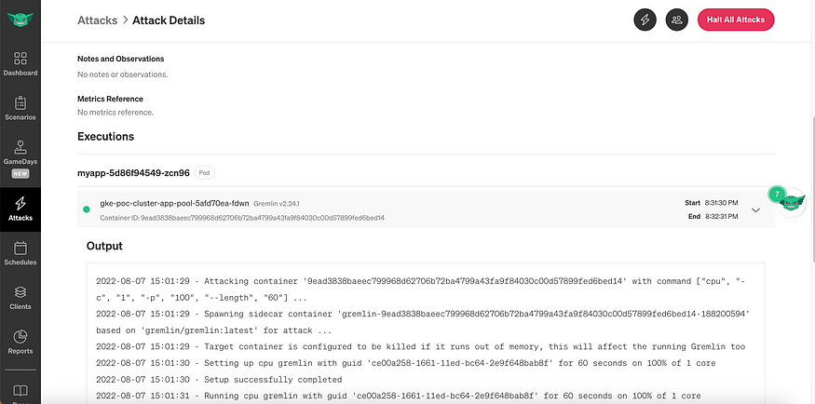

we can validate whether the Horizontal Pod Autoscaling defined for CPU Utilization by Nginx Pods working or not during the attack.

kubectl get pods -n app -w

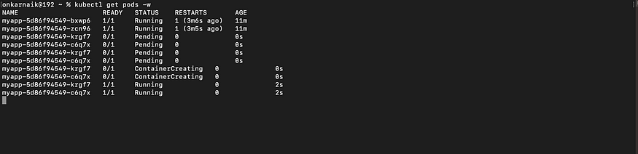

We can see that GKE HPA scaling up the Nginx Pods to count 4 as Max Count we defined is 4.

kubectl get hpa



In this way, by running CPU or Memory attacks we can validate the HPA defined for the application.

**CPU attacks can answer questions such as:**

* How is the user experience impacted when CPU resources are exhausted?
* Do I have monitoring and alerting in place to detect CPU spikes?
* Do I have quotas configured to limit CPU by application or process or container?
* Do I have cleanup scripts to get rid of corrupted threads?

**Validating Nginx Web App High Availability with Gremlin Blackhole Attack on GKE Load Balancer**

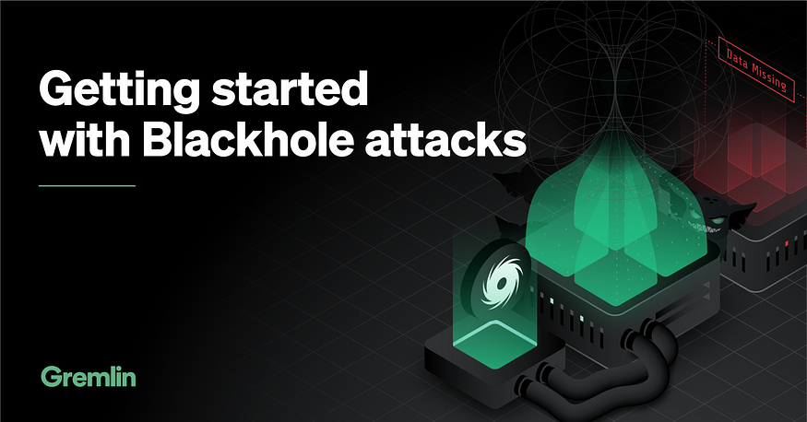

Blackhole attacks let you simulate these outages by dropping network traffic between services. This lets you uncover hard dependencies, test fallback, and failover mechanisms, and prepare your applications for unreliable networks.

For Blackhole Attack choose the type of attack as the Blackhole attack from Network Attacks and configure more details for the attack like Port details etc.

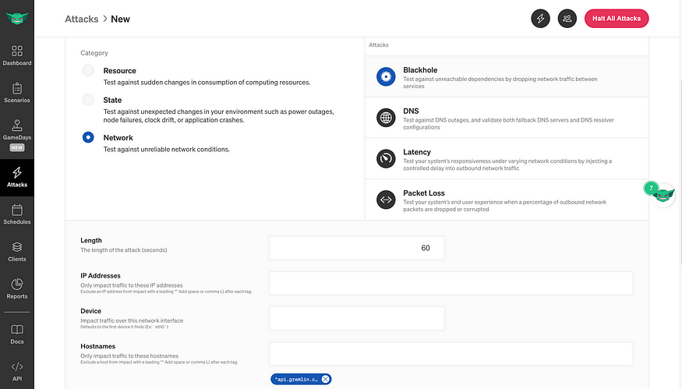

In our case, we have Nginx Deployment running on port 80.

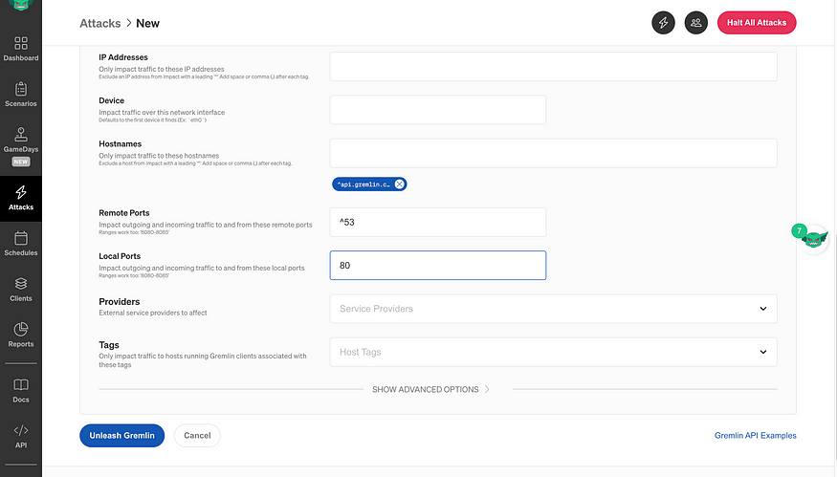

**Running Gremlin Blackhole Attack**

Click on attack details to see the attack details and output of the attack which Gremlin is running on Nginx Deployment Pods.

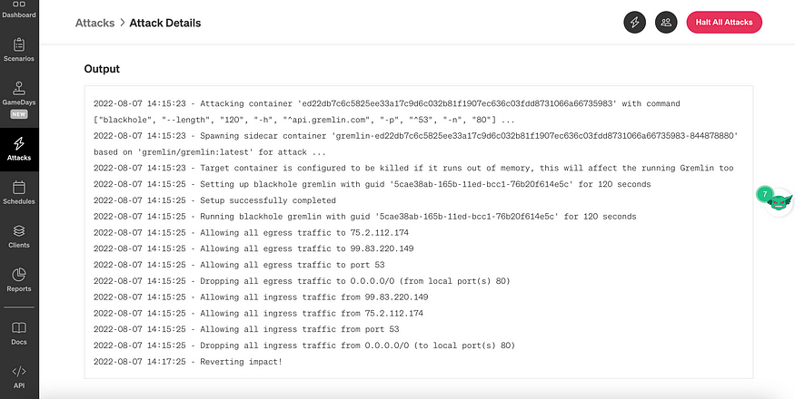

We can check the Nginx web page status from the GCP Load Balancer External IP. There is no latency or blockage in terms of web experience due to high availability and GCP Load Balancing between multiple backend pods.

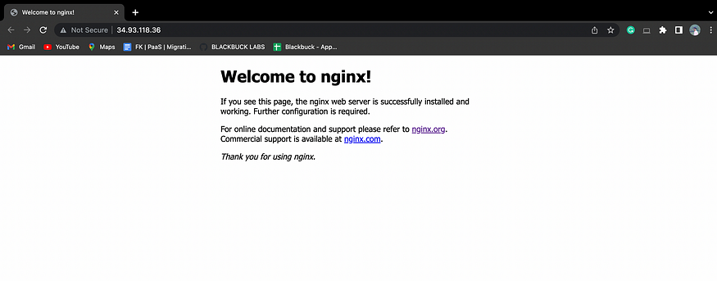

**Blackhole attacks can answer questions such as:**

* Where do dependencies exist within our system?
* Do we have monitoring in place to alert on the unavailability of each service?
* Does our application gracefully degrade if a dependency is unavailable?
* Is the user experience negatively affected when a downstream dependency is unavailable?
* Do we have dependencies that we think are non-critical, but can actually bring down our entire application?

For the **notification** part, we have configured **the slack Integration with the Gremlin web app**, by which we get all the notifications in the slack channel regarding the status of each Gremlin attack we perform on GKE.

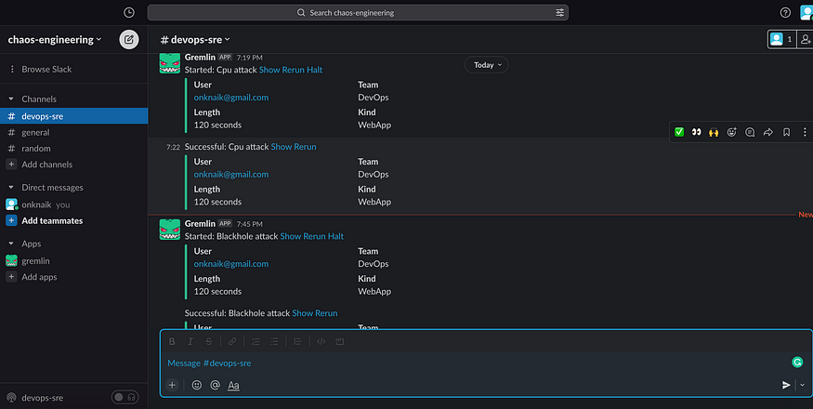

**Conclusion**



The overarching goal of Chaos Engineering is to improve the reliability of our applications and systems by testing how they handle failure. To do this, we need to take a structured and well-organized approach with clearly defined objectives and key performance indicators (KPIs).

Running random experiments without any direction or oversight won’t yield actionable results and will put our systems at unnecessary risk.

To meet the high-level goal of improved reliability, we need to guide our Chaos Engineering adoption process using more granular objectives.

**Questions?**

If you have any questions, I’ll be happy to read them in the comments. Follow me on [medium](https://medium.com/@onkar17) or [LinkedIn](https://www.linkedin.com/in/onkar17/).

[Google Cloud Platform](https://medium.com/tag/google-cloud-platform?source=post_page-----2568f9fc70c9---------------google_cloud_platform-----------------)

[Chaos Engineering](https://medium.com/tag/chaos-engineering?source=post_page-----2568f9fc70c9---------------chaos_engineering-----------------)

[Security](https://medium.com/tag/security?source=post_page-----2568f9fc70c9---------------security-----------------)

[Sre](https://medium.com/tag/sre?source=post_page-----2568f9fc70c9---------------sre-----------------)

[Gcp Security Operations](https://medium.com/tag/gcp-security-operations?source=post_page-----2568f9fc70c9---------------gcp_security_operations-----------------)

25

[[](https://medium.com/@onkar17?source=post_page-----2568f9fc70c9--------------------------------)](https://medium.com/@onkar17?source=post_page-----2568f9fc70c9--------------------------------)

[[](https://medium.com/google-cloud?source=post_page-----2568f9fc70c9--------------------------------)](https://medium.com/google-cloud?source=post_page-----2568f9fc70c9--------------------------------)

[Written by Onkar Naik](https://medium.com/@onkar17?source=post_page-----2568f9fc70c9--------------------------------)

[79 Followers](https://medium.com/@onkar17/followers?source=post_page-----2568f9fc70c9--------------------------------)

·Writer for

[Google Cloud - Community](https://medium.com/google-cloud?source=post_page-----2568f9fc70c9--------------------------------)

Google Cloud Champions Innovators

Follow

More from Onkar Naik and Google Cloud - Community

[[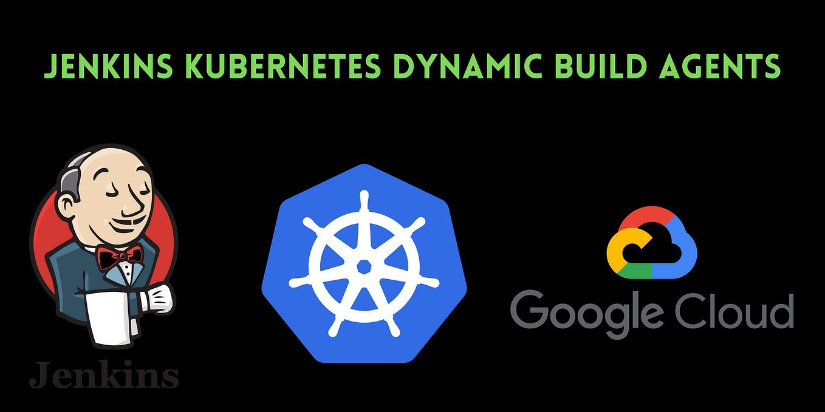](https://medium.com/searce/jenkins-distributed-cluster-using-dynamic-build-agents-on-gke-e2262a59dcb3?source=author_recirc-----2568f9fc70c9----0---------------------73dd8240_26b0_4c6e_98b6_5215f576ce3f-------)](https://medium.com/searce/jenkins-distributed-cluster-using-dynamic-build-agents-on-gke-e2262a59dcb3?source=author_recirc-----2568f9fc70c9----0---------------------73dd8240_26b0_4c6e_98b6_5215f576ce3f-------)

[[](https://medium.com/@onkar17?source=author_recirc-----2568f9fc70c9----0---------------------73dd8240_26b0_4c6e_98b6_5215f576ce3f-------)](https://medium.com/@onkar17?source=author_recirc-----2568f9fc70c9----0---------------------73dd8240_26b0_4c6e_98b6_5215f576ce3f-------)

[Onkar Naik](https://medium.com/@onkar17?source=author_recirc-----2568f9fc70c9----0---------------------73dd8240_26b0_4c6e_98b6_5215f576ce3f-------)

in

[Searce](https://medium.com/searce?source=author_recirc-----2568f9fc70c9----0---------------------73dd8240_26b0_4c6e_98b6_5215f576ce3f-------)

**[Jenkins Distributed Cluster Using Dynamic Build Agents On GKE](https://medium.com/searce/jenkins-distributed-cluster-using-dynamic-build-agents-on-gke-e2262a59dcb3?source=author_recirc-----2568f9fc70c9----0---------------------73dd8240_26b0_4c6e_98b6_5215f576ce3f-------)**

[This Article is based on how to set up Jenkins Distributed Cluster in GKE with Dynamic Build Agents on Kubernetes Pods.](https://medium.com/searce/jenkins-distributed-cluster-using-dynamic-build-agents-on-gke-e2262a59dcb3?source=author_recirc-----2568f9fc70c9----0---------------------73dd8240_26b0_4c6e_98b6_5215f576ce3f-------)

[15 min read·Jul 1, 2022](https://medium.com/searce/jenkins-distributed-cluster-using-dynamic-build-agents-on-gke-e2262a59dcb3?source=author_recirc-----2568f9fc70c9----0---------------------73dd8240_26b0_4c6e_98b6_5215f576ce3f-------)

23

[[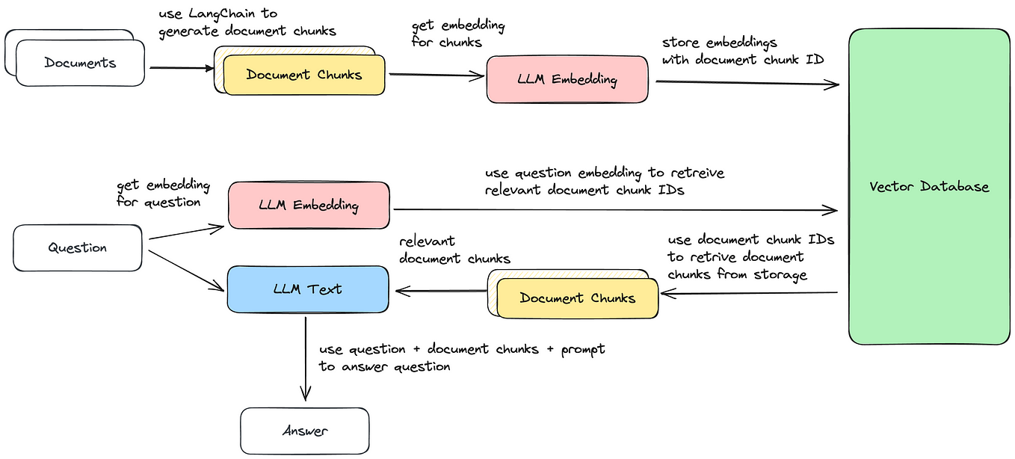](https://medium.com/google-cloud/generative-ai-document-retrieval-and-question-answering-with-llms-2b0fb80ae76d?source=author_recirc-----2568f9fc70c9----1---------------------73dd8240_26b0_4c6e_98b6_5215f576ce3f-------)](https://medium.com/google-cloud/generative-ai-document-retrieval-and-question-answering-with-llms-2b0fb80ae76d?source=author_recirc-----2568f9fc70c9----1---------------------73dd8240_26b0_4c6e_98b6_5215f576ce3f-------)

[[](https://medium.com/@saschaheyer?source=author_recirc-----2568f9fc70c9----1---------------------73dd8240_26b0_4c6e_98b6_5215f576ce3f-------)](https://medium.com/@saschaheyer?source=author_recirc-----2568f9fc70c9----1---------------------73dd8240_26b0_4c6e_98b6_5215f576ce3f-------)

[Sascha Heyer](https://medium.com/@saschaheyer?source=author_recirc-----2568f9fc70c9----1---------------------73dd8240_26b0_4c6e_98b6_5215f576ce3f-------)

in

[Google Cloud - Community](https://medium.com/google-cloud?source=author_recirc-----2568f9fc70c9----1---------------------73dd8240_26b0_4c6e_98b6_5215f576ce3f-------)

**[Generative AI - Document Retrieval and Question Answering with LLMs](https://medium.com/google-cloud/generative-ai-document-retrieval-and-question-answering-with-llms-2b0fb80ae76d?source=author_recirc-----2568f9fc70c9----1---------------------73dd8240_26b0_4c6e_98b6_5215f576ce3f-------)**

[Apply LLMs to your domain-specific data](https://medium.com/google-cloud/generative-ai-document-retrieval-and-question-answering-with-llms-2b0fb80ae76d?source=author_recirc-----2568f9fc70c9----1---------------------73dd8240_26b0_4c6e_98b6_5215f576ce3f-------)

[·7 min read·Jun 5](https://medium.com/google-cloud/generative-ai-document-retrieval-and-question-answering-with-llms-2b0fb80ae76d?source=author_recirc-----2568f9fc70c9----1---------------------73dd8240_26b0_4c6e_98b6_5215f576ce3f-------)

152

[6](https://medium.com/google-cloud/generative-ai-document-retrieval-and-question-answering-with-llms-2b0fb80ae76d?responsesOpen=true&sortBy=REVERSE_CHRON&source=author_recirc-----2568f9fc70c9----1---------------------73dd8240_26b0_4c6e_98b6_5215f576ce3f-------)

[[](https://medium.com/google-cloud/bigquery-breaking-news-generative-ai-8c6d14bd4568?source=author_recirc-----2568f9fc70c9----2---------------------73dd8240_26b0_4c6e_98b6_5215f576ce3f-------)](https://medium.com/google-cloud/bigquery-breaking-news-generative-ai-8c6d14bd4568?source=author_recirc-----2568f9fc70c9----2---------------------73dd8240_26b0_4c6e_98b6_5215f576ce3f-------)

[[](https://medium.com/@an_14796?source=author_recirc-----2568f9fc70c9----2---------------------73dd8240_26b0_4c6e_98b6_5215f576ce3f-------)](https://medium.com/@an_14796?source=author_recirc-----2568f9fc70c9----2---------------------73dd8240_26b0_4c6e_98b6_5215f576ce3f-------)

[Artem Nikulchenko](https://medium.com/@an_14796?source=author_recirc-----2568f9fc70c9----2---------------------73dd8240_26b0_4c6e_98b6_5215f576ce3f-------)

in

[Google Cloud - Community](https://medium.com/google-cloud?source=author_recirc-----2568f9fc70c9----2---------------------73dd8240_26b0_4c6e_98b6_5215f576ce3f-------)

**[BigQuery Breaking News — Generative AI](https://medium.com/google-cloud/bigquery-breaking-news-generative-ai-8c6d14bd4568?source=author_recirc-----2568f9fc70c9----2---------------------73dd8240_26b0_4c6e_98b6_5215f576ce3f-------)**

[Happy day for fans of BigQuery and Generative AI! BigQuery now has direct access to the latest text-bison LLM](https://medium.com/google-cloud/bigquery-breaking-news-generative-ai-8c6d14bd4568?source=author_recirc-----2568f9fc70c9----2---------------------73dd8240_26b0_4c6e_98b6_5215f576ce3f-------)

[4 min read·Jun 18](https://medium.com/google-cloud/bigquery-breaking-news-generative-ai-8c6d14bd4568?source=author_recirc-----2568f9fc70c9----2---------------------73dd8240_26b0_4c6e_98b6_5215f576ce3f-------)

110

[1](https://medium.com/google-cloud/bigquery-breaking-news-generative-ai-8c6d14bd4568?responsesOpen=true&sortBy=REVERSE_CHRON&source=author_recirc-----2568f9fc70c9----2---------------------73dd8240_26b0_4c6e_98b6_5215f576ce3f-------)

[[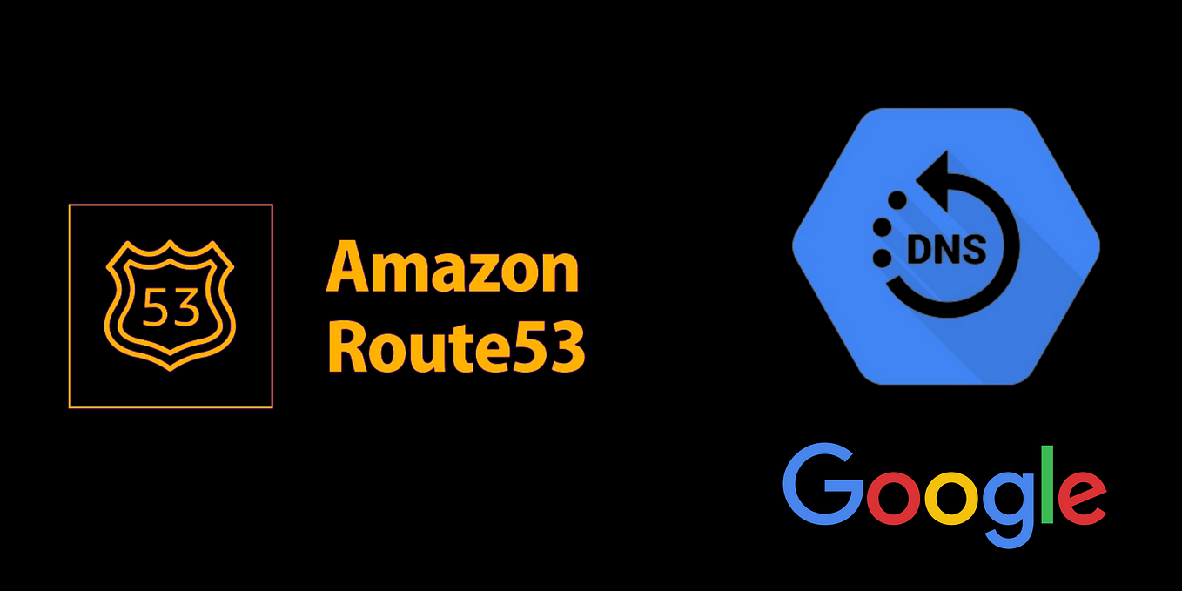](https://medium.com/searce/multi-cloud-private-dns-forwarding-a77718e2a3f9?source=author_recirc-----2568f9fc70c9----3---------------------73dd8240_26b0_4c6e_98b6_5215f576ce3f-------)](https://medium.com/searce/multi-cloud-private-dns-forwarding-a77718e2a3f9?source=author_recirc-----2568f9fc70c9----3---------------------73dd8240_26b0_4c6e_98b6_5215f576ce3f-------)

[[](https://medium.com/@onkar17?source=author_recirc-----2568f9fc70c9----3---------------------73dd8240_26b0_4c6e_98b6_5215f576ce3f-------)](https://medium.com/@onkar17?source=author_recirc-----2568f9fc70c9----3---------------------73dd8240_26b0_4c6e_98b6_5215f576ce3f-------)

[Onkar Naik](https://medium.com/@onkar17?source=author_recirc-----2568f9fc70c9----3---------------------73dd8240_26b0_4c6e_98b6_5215f576ce3f-------)

in

[Searce](https://medium.com/searce?source=author_recirc-----2568f9fc70c9----3---------------------73dd8240_26b0_4c6e_98b6_5215f576ce3f-------)

**[Multi Cloud Private DNS Forwarding](https://medium.com/searce/multi-cloud-private-dns-forwarding-a77718e2a3f9?source=author_recirc-----2568f9fc70c9----3---------------------73dd8240_26b0_4c6e_98b6_5215f576ce3f-------)**

[This Article is based on how to setup Multi Cloud Private DNS Forwarding between Google Cloud and AWS Cloud.](https://medium.com/searce/multi-cloud-private-dns-forwarding-a77718e2a3f9?source=author_recirc-----2568f9fc70c9----3---------------------73dd8240_26b0_4c6e_98b6_5215f576ce3f-------)

[12 min read·Jan 24, 2022](https://medium.com/searce/multi-cloud-private-dns-forwarding-a77718e2a3f9?source=author_recirc-----2568f9fc70c9----3---------------------73dd8240_26b0_4c6e_98b6_5215f576ce3f-------)

16

[1](https://medium.com/searce/multi-cloud-private-dns-forwarding-a77718e2a3f9?responsesOpen=true&sortBy=REVERSE_CHRON&source=author_recirc-----2568f9fc70c9----3---------------------73dd8240_26b0_4c6e_98b6_5215f576ce3f-------)

[See all from Onkar Naik](https://medium.com/@onkar17?source=post_page-----2568f9fc70c9--------------------------------)

[See all from Google Cloud - Community](https://medium.com/google-cloud?source=post_page-----2568f9fc70c9--------------------------------)

Recommended from Medium

[[](https://medium.com/@prajwalt/is-it-worth-getting-gcp-professional-cloud-architect-dd653e65d4bb?source=read_next_recirc-----2568f9fc70c9----0---------------------91b39d11_1a9d_41cd_87e5_c077ee97ba68-------)](https://medium.com/@prajwalt/is-it-worth-getting-gcp-professional-cloud-architect-dd653e65d4bb?source=read_next_recirc-----2568f9fc70c9----0---------------------91b39d11_1a9d_41cd_87e5_c077ee97ba68-------)

[[](https://medium.com/@prajwalt?source=read_next_recirc-----2568f9fc70c9----0---------------------91b39d11_1a9d_41cd_87e5_c077ee97ba68-------)](https://medium.com/@prajwalt?source=read_next_recirc-----2568f9fc70c9----0---------------------91b39d11_1a9d_41cd_87e5_c077ee97ba68-------)

[Prajwal T](https://medium.com/@prajwalt?source=read_next_recirc-----2568f9fc70c9----0---------------------91b39d11_1a9d_41cd_87e5_c077ee97ba68-------)

**[Is it worth getting GCP Professional Cloud Architect?](https://medium.com/@prajwalt/is-it-worth-getting-gcp-professional-cloud-architect-dd653e65d4bb?source=read_next_recirc-----2568f9fc70c9----0---------------------91b39d11_1a9d_41cd_87e5_c077ee97ba68-------)**

[My experience with GCP Professional Cloud Architect](https://medium.com/@prajwalt/is-it-worth-getting-gcp-professional-cloud-architect-dd653e65d4bb?source=read_next_recirc-----2568f9fc70c9----0---------------------91b39d11_1a9d_41cd_87e5_c077ee97ba68-------)

[·4 min read·Feb 14](https://medium.com/@prajwalt/is-it-worth-getting-gcp-professional-cloud-architect-dd653e65d4bb?source=read_next_recirc-----2568f9fc70c9----0---------------------91b39d11_1a9d_41cd_87e5_c077ee97ba68-------)

31

[[](https://medium.com/artificial-corner/youre-using-chatgpt-wrong-here-s-how-to-be-ahead-of-99-of-chatgpt-users-886a50dabc54?source=read_next_recirc-----2568f9fc70c9----1---------------------91b39d11_1a9d_41cd_87e5_c077ee97ba68-------)](https://medium.com/artificial-corner/youre-using-chatgpt-wrong-here-s-how-to-be-ahead-of-99-of-chatgpt-users-886a50dabc54?source=read_next_recirc-----2568f9fc70c9----1---------------------91b39d11_1a9d_41cd_87e5_c077ee97ba68-------)

[[](https://medium.com/@frank-andrade?source=read_next_recirc-----2568f9fc70c9----1---------------------91b39d11_1a9d_41cd_87e5_c077ee97ba68-------)](https://medium.com/@frank-andrade?source=read_next_recirc-----2568f9fc70c9----1---------------------91b39d11_1a9d_41cd_87e5_c077ee97ba68-------)

[The PyCoach](https://medium.com/@frank-andrade?source=read_next_recirc-----2568f9fc70c9----1---------------------91b39d11_1a9d_41cd_87e5_c077ee97ba68-------)

in

[Artificial Corner](https://medium.com/artificial-corner?source=read_next_recirc-----2568f9fc70c9----1---------------------91b39d11_1a9d_41cd_87e5_c077ee97ba68-------)

**[You’re Using ChatGPT Wrong! Here’s How to Be Ahead of 99% of ChatGPT Users](https://medium.com/artificial-corner/youre-using-chatgpt-wrong-here-s-how-to-be-ahead-of-99-of-chatgpt-users-886a50dabc54?source=read_next_recirc-----2568f9fc70c9----1---------------------91b39d11_1a9d_41cd_87e5_c077ee97ba68-------)**

[Master ChatGPT by learning prompt engineering.](https://medium.com/artificial-corner/youre-using-chatgpt-wrong-here-s-how-to-be-ahead-of-99-of-chatgpt-users-886a50dabc54?source=read_next_recirc-----2568f9fc70c9----1---------------------91b39d11_1a9d_41cd_87e5_c077ee97ba68-------)

[·7 min read·Mar 17](https://medium.com/artificial-corner/youre-using-chatgpt-wrong-here-s-how-to-be-ahead-of-99-of-chatgpt-users-886a50dabc54?source=read_next_recirc-----2568f9fc70c9----1---------------------91b39d11_1a9d_41cd_87e5_c077ee97ba68-------)

28K

[516](https://medium.com/artificial-corner/youre-using-chatgpt-wrong-here-s-how-to-be-ahead-of-99-of-chatgpt-users-886a50dabc54?responsesOpen=true&sortBy=REVERSE_CHRON&source=read_next_recirc-----2568f9fc70c9----1---------------------91b39d11_1a9d_41cd_87e5_c077ee97ba68-------)

Lists

[[](https://medium.com/@anupamchugh/list/now-in-ai-handpicked-by-better-programming-b788e9676cd5?source=read_next_recirc-----2568f9fc70c9--------------------------------)](https://medium.com/@anupamchugh/list/now-in-ai-handpicked-by-better-programming-b788e9676cd5?source=read_next_recirc-----2568f9fc70c9--------------------------------)

[[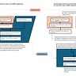](https://medium.com/@anupamchugh/list/now-in-ai-handpicked-by-better-programming-b788e9676cd5?source=read_next_recirc-----2568f9fc70c9--------------------------------)](https://medium.com/@anupamchugh/list/now-in-ai-handpicked-by-better-programming-b788e9676cd5?source=read_next_recirc-----2568f9fc70c9--------------------------------)

[[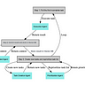](https://medium.com/@anupamchugh/list/now-in-ai-handpicked-by-better-programming-b788e9676cd5?source=read_next_recirc-----2568f9fc70c9--------------------------------)](https://medium.com/@anupamchugh/list/now-in-ai-handpicked-by-better-programming-b788e9676cd5?source=read_next_recirc-----2568f9fc70c9--------------------------------)

[Now in AI: Handpicked by Better Programming](https://medium.com/@anupamchugh/list/now-in-ai-handpicked-by-better-programming-b788e9676cd5?source=read_next_recirc-----2568f9fc70c9--------------------------------)

[260 stories·42 saves](https://medium.com/@anupamchugh/list/now-in-ai-handpicked-by-better-programming-b788e9676cd5?source=read_next_recirc-----2568f9fc70c9--------------------------------)

[[](https://medium.com/@blyum2007/list/marketing-35b53c961d59?source=read_next_recirc-----2568f9fc70c9--------------------------------)](https://medium.com/@blyum2007/list/marketing-35b53c961d59?source=read_next_recirc-----2568f9fc70c9--------------------------------)

[[](https://medium.com/@blyum2007/list/marketing-35b53c961d59?source=read_next_recirc-----2568f9fc70c9--------------------------------)](https://medium.com/@blyum2007/list/marketing-35b53c961d59?source=read_next_recirc-----2568f9fc70c9--------------------------------)

[[](https://medium.com/@blyum2007/list/marketing-35b53c961d59?source=read_next_recirc-----2568f9fc70c9--------------------------------)](https://medium.com/@blyum2007/list/marketing-35b53c961d59?source=read_next_recirc-----2568f9fc70c9--------------------------------)

[marketing](https://medium.com/@blyum2007/list/marketing-35b53c961d59?source=read_next_recirc-----2568f9fc70c9--------------------------------)

[113 stories·32 saves](https://medium.com/@blyum2007/list/marketing-35b53c961d59?source=read_next_recirc-----2568f9fc70c9--------------------------------)

[[](https://medium.com/@william.dai/list/newreadinglist-d8e941a8265f?source=read_next_recirc-----2568f9fc70c9--------------------------------)](https://medium.com/@william.dai/list/newreadinglist-d8e941a8265f?source=read_next_recirc-----2568f9fc70c9--------------------------------)

[[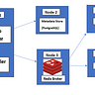](https://medium.com/@william.dai/list/newreadinglist-d8e941a8265f?source=read_next_recirc-----2568f9fc70c9--------------------------------)](https://medium.com/@william.dai/list/newreadinglist-d8e941a8265f?source=read_next_recirc-----2568f9fc70c9--------------------------------)

[[](https://medium.com/@william.dai/list/newreadinglist-d8e941a8265f?source=read_next_recirc-----2568f9fc70c9--------------------------------)](https://medium.com/@william.dai/list/newreadinglist-d8e941a8265f?source=read_next_recirc-----2568f9fc70c9--------------------------------)

[New\_Reading\_List](https://medium.com/@william.dai/list/newreadinglist-d8e941a8265f?source=read_next_recirc-----2568f9fc70c9--------------------------------)

[174 stories·27 saves](https://medium.com/@william.dai/list/newreadinglist-d8e941a8265f?source=read_next_recirc-----2568f9fc70c9--------------------------------)

[[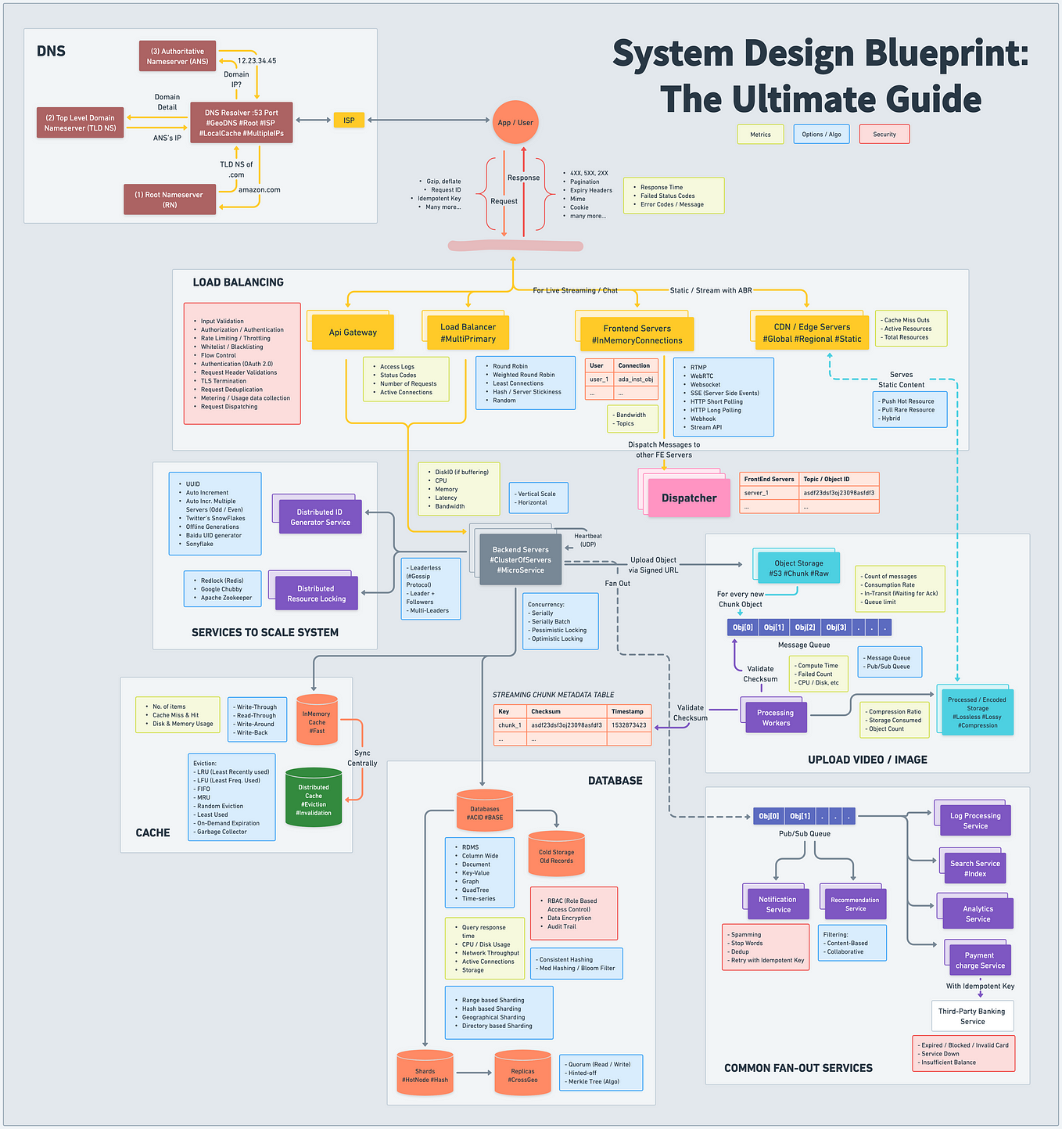](https://medium.com/bytebytego-system-design-alliance/system-design-blueprint-the-ultimate-guide-e27b914bf8f1?source=read_next_recirc-----2568f9fc70c9----0---------------------91b39d11_1a9d_41cd_87e5_c077ee97ba68-------)](https://medium.com/bytebytego-system-design-alliance/system-design-blueprint-the-ultimate-guide-e27b914bf8f1?source=read_next_recirc-----2568f9fc70c9----0---------------------91b39d11_1a9d_41cd_87e5_c077ee97ba68-------)

[[](https://medium.com/@zonito?source=read_next_recirc-----2568f9fc70c9----0---------------------91b39d11_1a9d_41cd_87e5_c077ee97ba68-------)](https://medium.com/@zonito?source=read_next_recirc-----2568f9fc70c9----0---------------------91b39d11_1a9d_41cd_87e5_c077ee97ba68-------)

[Love Sharma](https://medium.com/@zonito?source=read_next_recirc-----2568f9fc70c9----0---------------------91b39d11_1a9d_41cd_87e5_c077ee97ba68-------)

in

[ByteByteGo System Design Alliance](https://medium.com/bytebytego-system-design-alliance?source=read_next_recirc-----2568f9fc70c9----0---------------------91b39d11_1a9d_41cd_87e5_c077ee97ba68-------)

**[System Design Blueprint: The Ultimate Guide](https://medium.com/bytebytego-system-design-alliance/system-design-blueprint-the-ultimate-guide-e27b914bf8f1?source=read_next_recirc-----2568f9fc70c9----0---------------------91b39d11_1a9d_41cd_87e5_c077ee97ba68-------)**

[Developing a robust, scalable, and efficient system can be daunting. However, understanding the key concepts and components can make the…](https://medium.com/bytebytego-system-design-alliance/system-design-blueprint-the-ultimate-guide-e27b914bf8f1?source=read_next_recirc-----2568f9fc70c9----0---------------------91b39d11_1a9d_41cd_87e5_c077ee97ba68-------)

[·9 min read·Apr 20](https://medium.com/bytebytego-system-design-alliance/system-design-blueprint-the-ultimate-guide-e27b914bf8f1?source=read_next_recirc-----2568f9fc70c9----0---------------------91b39d11_1a9d_41cd_87e5_c077ee97ba68-------)

6.3K

[52](https://medium.com/bytebytego-system-design-alliance/system-design-blueprint-the-ultimate-guide-e27b914bf8f1?responsesOpen=true&sortBy=REVERSE_CHRON&source=read_next_recirc-----2568f9fc70c9----0---------------------91b39d11_1a9d_41cd_87e5_c077ee97ba68-------)

[[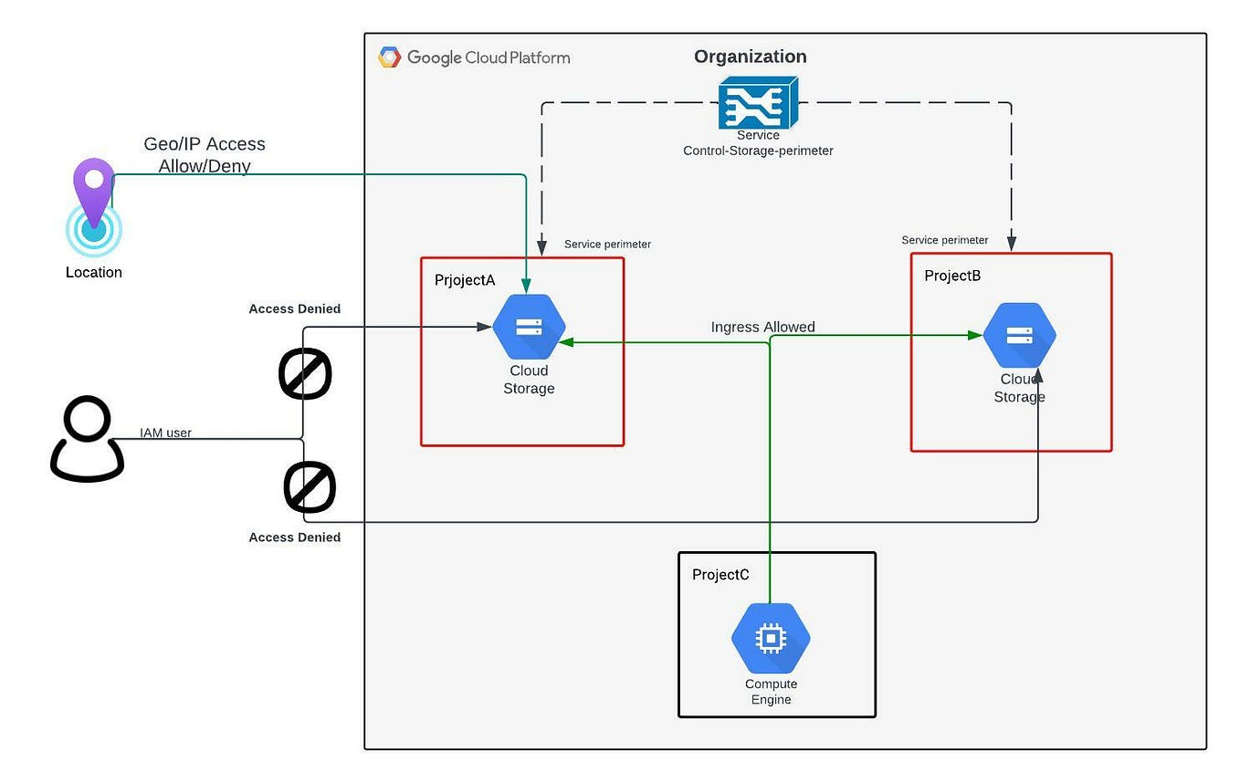](https://medium.com/google-cloud/google-cloud-vpc-service-control-b7785ac7092d?source=read_next_recirc-----2568f9fc70c9----1---------------------91b39d11_1a9d_41cd_87e5_c077ee97ba68-------)](https://medium.com/google-cloud/google-cloud-vpc-service-control-b7785ac7092d?source=read_next_recirc-----2568f9fc70c9----1---------------------91b39d11_1a9d_41cd_87e5_c077ee97ba68-------)

[[](https://medium.com/@lyfedge799?source=read_next_recirc-----2568f9fc70c9----1---------------------91b39d11_1a9d_41cd_87e5_c077ee97ba68-------)](https://medium.com/@lyfedge799?source=read_next_recirc-----2568f9fc70c9----1---------------------91b39d11_1a9d_41cd_87e5_c077ee97ba68-------)

[Sumit K](https://medium.com/@lyfedge799?source=read_next_recirc-----2568f9fc70c9----1---------------------91b39d11_1a9d_41cd_87e5_c077ee97ba68-------)

in

[Google Cloud - Community](https://medium.com/google-cloud?source=read_next_recirc-----2568f9fc70c9----1---------------------91b39d11_1a9d_41cd_87e5_c077ee97ba68-------)

**[Google Cloud — VPC Service Control](https://medium.com/google-cloud/google-cloud-vpc-service-control-b7785ac7092d?source=read_next_recirc-----2568f9fc70c9----1---------------------91b39d11_1a9d_41cd_87e5_c077ee97ba68-------)**

[In this article, We will cover everything about VPC Service Control. What is VPC Service Control? How it works and why do we actually need…](https://medium.com/google-cloud/google-cloud-vpc-service-control-b7785ac7092d?source=read_next_recirc-----2568f9fc70c9----1---------------------91b39d11_1a9d_41cd_87e5_c077ee97ba68-------)

[8 min read·Jan 23](https://medium.com/google-cloud/google-cloud-vpc-service-control-b7785ac7092d?source=read_next_recirc-----2568f9fc70c9----1---------------------91b39d11_1a9d_41cd_87e5_c077ee97ba68-------)

64

[1](https://medium.com/google-cloud/google-cloud-vpc-service-control-b7785ac7092d?responsesOpen=true&sortBy=REVERSE_CHRON&source=read_next_recirc-----2568f9fc70c9----1---------------------91b39d11_1a9d_41cd_87e5_c077ee97ba68-------)

[[](https://medium.com/the-coding-diaries/why-experienced-programmers-fail-coding-interviews-b22210ba343?source=read_next_recirc-----2568f9fc70c9----2---------------------91b39d11_1a9d_41cd_87e5_c077ee97ba68-------)](https://medium.com/the-coding-diaries/why-experienced-programmers-fail-coding-interviews-b22210ba343?source=read_next_recirc-----2568f9fc70c9----2---------------------91b39d11_1a9d_41cd_87e5_c077ee97ba68-------)

[[](https://medium.com/@thecodingdiaries?source=read_next_recirc-----2568f9fc70c9----2---------------------91b39d11_1a9d_41cd_87e5_c077ee97ba68-------)](https://medium.com/@thecodingdiaries?source=read_next_recirc-----2568f9fc70c9----2---------------------91b39d11_1a9d_41cd_87e5_c077ee97ba68-------)

[The Coding Diaries](https://medium.com/@thecodingdiaries?source=read_next_recirc-----2568f9fc70c9----2---------------------91b39d11_1a9d_41cd_87e5_c077ee97ba68-------)

in

[The Coding Diaries](https://medium.com/the-coding-diaries?source=read_next_recirc-----2568f9fc70c9----2---------------------91b39d11_1a9d_41cd_87e5_c077ee97ba68-------)

**[Why Experienced Programmers Fail Coding Interviews](https://medium.com/the-coding-diaries/why-experienced-programmers-fail-coding-interviews-b22210ba343?source=read_next_recirc-----2568f9fc70c9----2---------------------91b39d11_1a9d_41cd_87e5_c077ee97ba68-------)**

[A friend of mine recently joined a FAANG company as an engineering manager, and found themselves in the position of recruiting for…](https://medium.com/the-coding-diaries/why-experienced-programmers-fail-coding-interviews-b22210ba343?source=read_next_recirc-----2568f9fc70c9----2---------------------91b39d11_1a9d_41cd_87e5_c077ee97ba68-------)

[·5 min read·Nov 2, 2022](https://medium.com/the-coding-diaries/why-experienced-programmers-fail-coding-interviews-b22210ba343?source=read_next_recirc-----2568f9fc70c9----2---------------------91b39d11_1a9d_41cd_87e5_c077ee97ba68-------)

5.4K

[111](https://medium.com/the-coding-diaries/why-experienced-programmers-fail-coding-interviews-b22210ba343?responsesOpen=true&sortBy=REVERSE_CHRON&source=read_next_recirc-----2568f9fc70c9----2---------------------91b39d11_1a9d_41cd_87e5_c077ee97ba68-------)

[[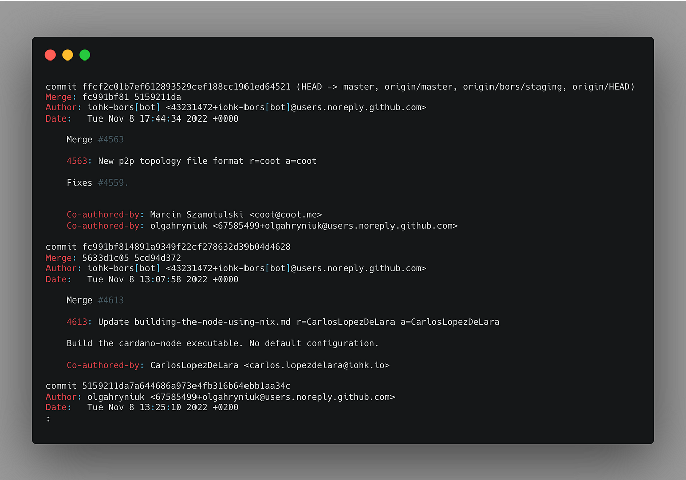](https://medium.com/gitconnected/use-git-like-a-senior-engineer-ef6d741c898e?source=read_next_recirc-----2568f9fc70c9----3---------------------91b39d11_1a9d_41cd_87e5_c077ee97ba68-------)](https://medium.com/gitconnected/use-git-like-a-senior-engineer-ef6d741c898e?source=read_next_recirc-----2568f9fc70c9----3---------------------91b39d11_1a9d_41cd_87e5_c077ee97ba68-------)

[[](https://medium.com/@jacobistyping?source=read_next_recirc-----2568f9fc70c9----3---------------------91b39d11_1a9d_41cd_87e5_c077ee97ba68-------)](https://medium.com/@jacobistyping?source=read_next_recirc-----2568f9fc70c9----3---------------------91b39d11_1a9d_41cd_87e5_c077ee97ba68-------)

[Jacob Bennett](https://medium.com/@jacobistyping?source=read_next_recirc-----2568f9fc70c9----3---------------------91b39d11_1a9d_41cd_87e5_c077ee97ba68-------)

in

[Level Up Coding](https://medium.com/gitconnected?source=read_next_recirc-----2568f9fc70c9----3---------------------91b39d11_1a9d_41cd_87e5_c077ee97ba68-------)

**[Use Git like a senior engineer](https://medium.com/gitconnected/use-git-like-a-senior-engineer-ef6d741c898e?source=read_next_recirc-----2568f9fc70c9----3---------------------91b39d11_1a9d_41cd_87e5_c077ee97ba68-------)**

[Git is a powerful tool that feels great to use when you know how to use it.](https://medium.com/gitconnected/use-git-like-a-senior-engineer-ef6d741c898e?source=read_next_recirc-----2568f9fc70c9----3---------------------91b39d11_1a9d_41cd_87e5_c077ee97ba68-------)

[·4 min read·Nov 15, 2022](https://medium.com/gitconnected/use-git-like-a-senior-engineer-ef6d741c898e?source=read_next_recirc-----2568f9fc70c9----3---------------------91b39d11_1a9d_41cd_87e5_c077ee97ba68-------)

7.6K

[78](https://medium.com/gitconnected/use-git-like-a-senior-engineer-ef6d741c898e?responsesOpen=true&sortBy=REVERSE_CHRON&source=read_next_recirc-----2568f9fc70c9----3---------------------91b39d11_1a9d_41cd_87e5_c077ee97ba68-------)

[See more recommendations](https://medium.com/?source=post_page-----2568f9fc70c9--------------------------------)

[Help](https://help.medium.com/hc/en-us?source=post_page-----2568f9fc70c9--------------------------------)

[Status](https://medium.statuspage.io/?source=post_page-----2568f9fc70c9--------------------------------)

[Writers](https://about.medium.com/creators/?source=post_page-----2568f9fc70c9--------------------------------)

[Blog](https://blog.medium.com/?source=post_page-----2568f9fc70c9--------------------------------)

[Careers](https://medium.com/jobs-at-medium/work-at-medium-959d1a85284e?source=post_page-----2568f9fc70c9--------------------------------)

[Privacy](https://policy.medium.com/medium-privacy-policy-f03bf92035c9?source=post_page-----2568f9fc70c9--------------------------------)

[Terms](https://policy.medium.com/medium-terms-of-service-9db0094a1e0f?source=post_page-----2568f9fc70c9--------------------------------)

[About](https://medium.com/about?autoplay=1&source=post_page-----2568f9fc70c9--------------------------------)

[Text to speech](https://speechify.com/medium?source=post_page-----2568f9fc70c9--------------------------------)

[Teams](https://medium.com/business?source=post_page-----2568f9fc70c9--------------------------------)